Express pRoject

Bikin Foleder kosonh

Open New Folder

Integrated terminal

NPM INIT

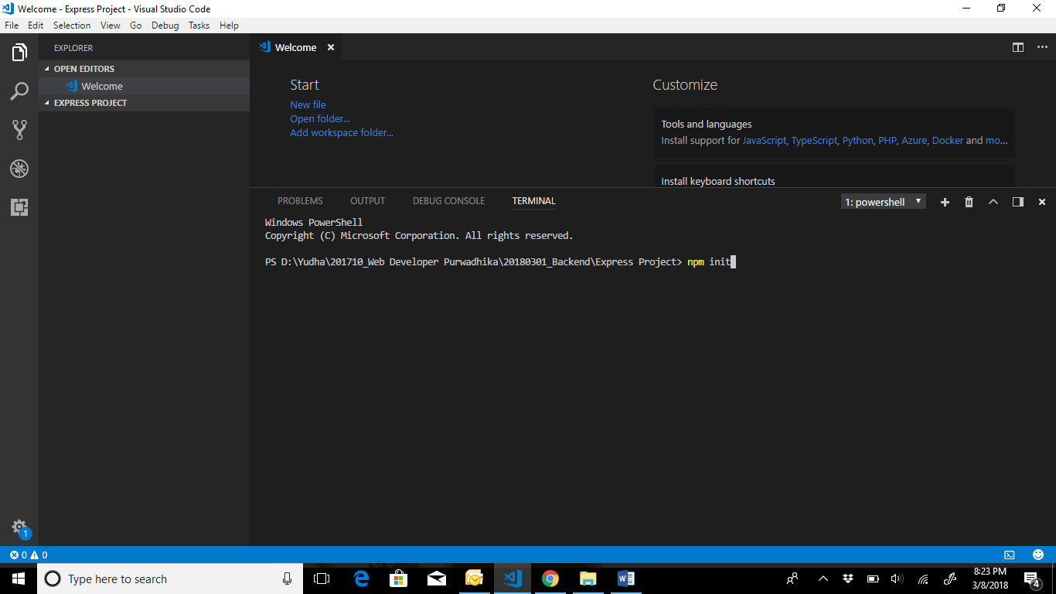

Kasi name trus enter sampai create package.json

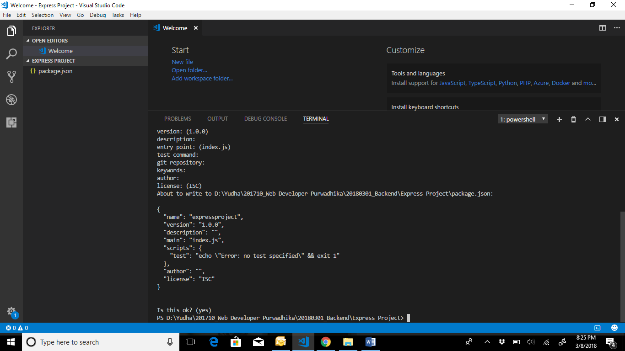

npm install express –save

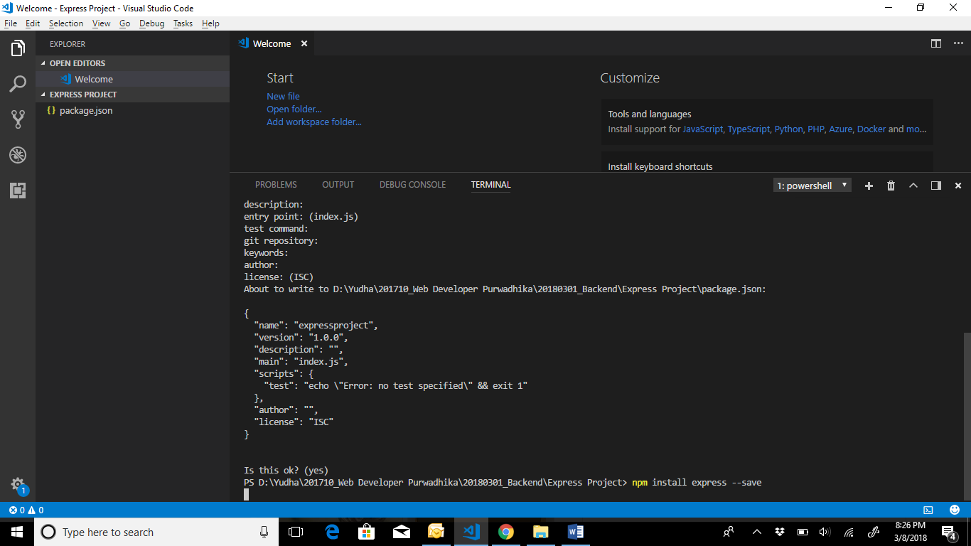

Keluar node module di kiri

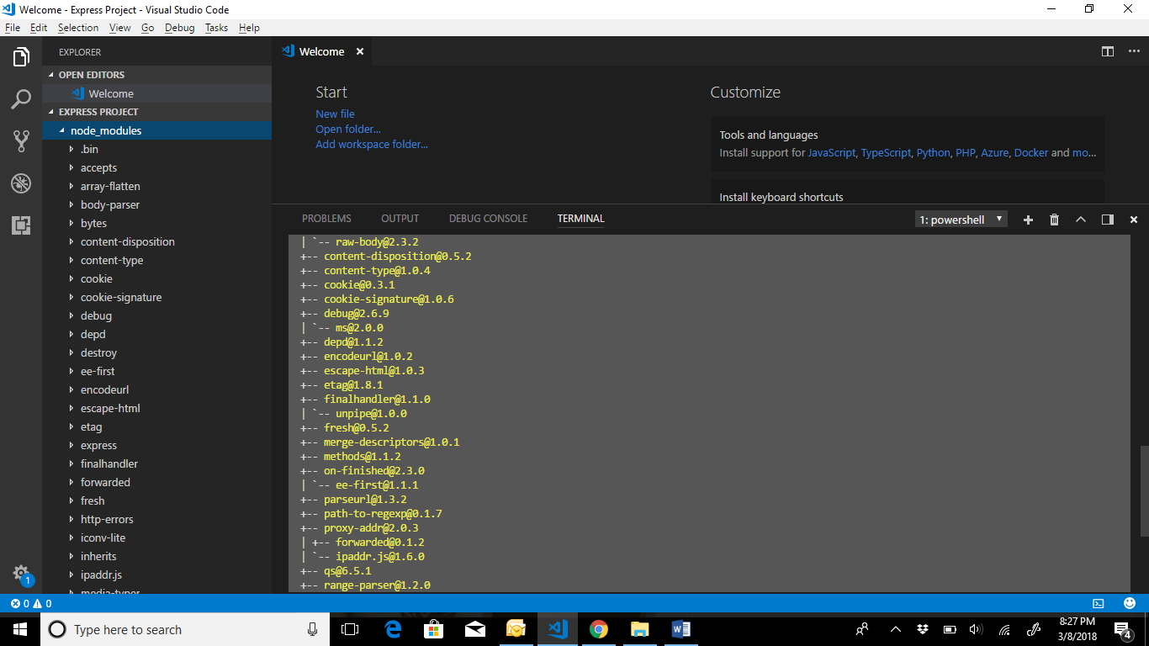

Buat File baru server.js

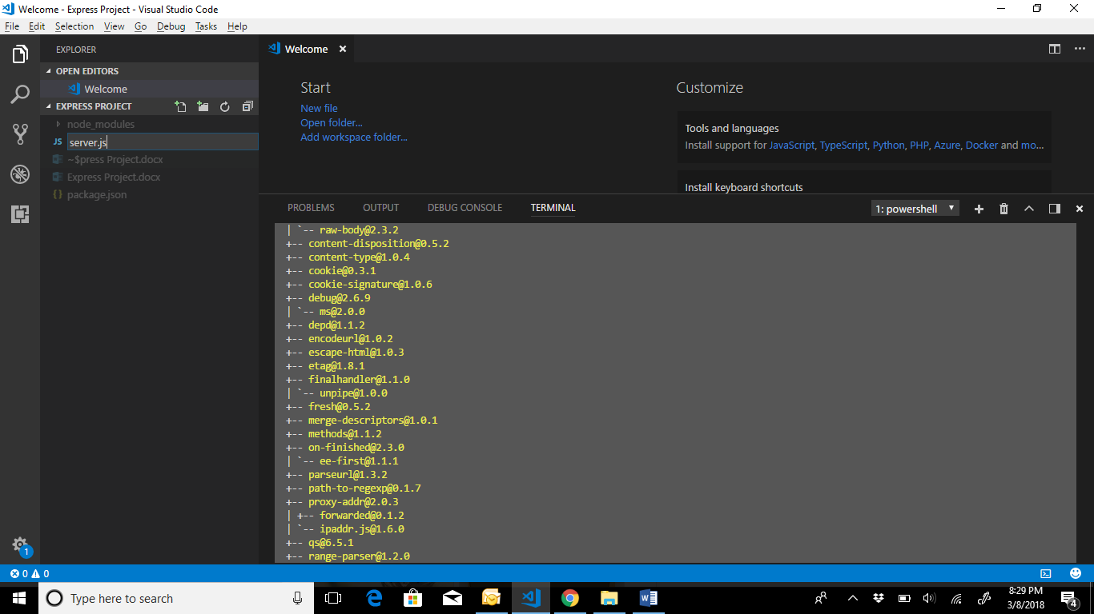

Ketik di server.js

const express = require ('express')

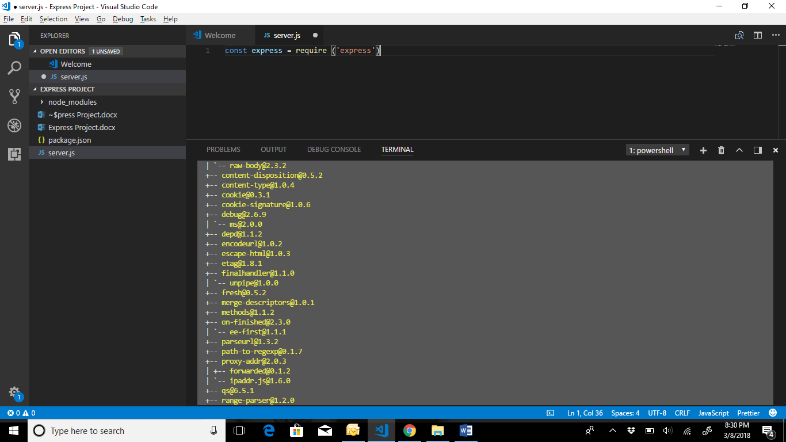

const app = express()

hasil compiling express masuk ke app

//calling library

const express = require ('express')

const app = express()

app.get('/', res => {

res.send('Hello World')

})

app.listen(3000)

di package.json

{

"name": "expressproject",

"version": "1.0.0",

"description": "",

"main": "index.js",

"scripts": {

"test": "echo \"Error: no test specified\" && exit 1",

"start": "node server.js"

},

"author": "",

"license": "ISC",

"dependencies": {

"express": "^4.16.2"

}

}

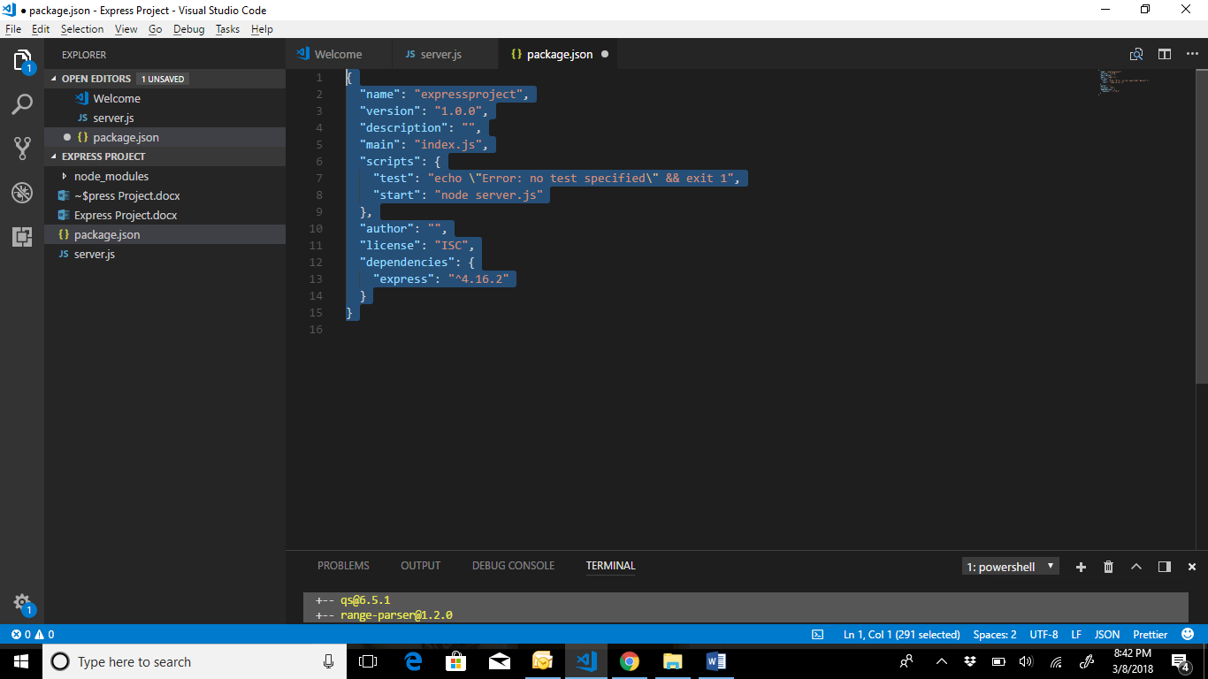

Npm start

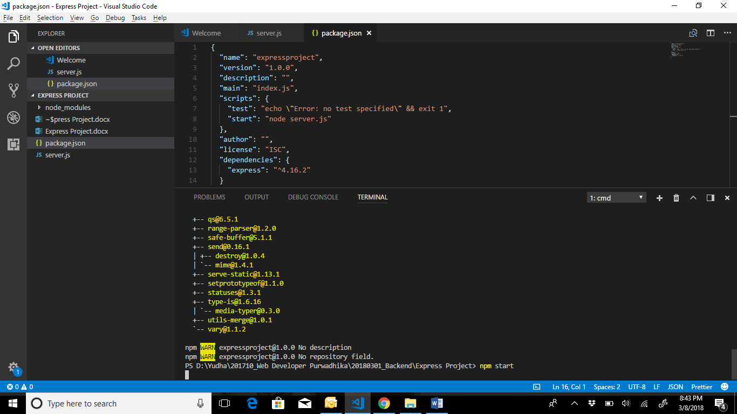

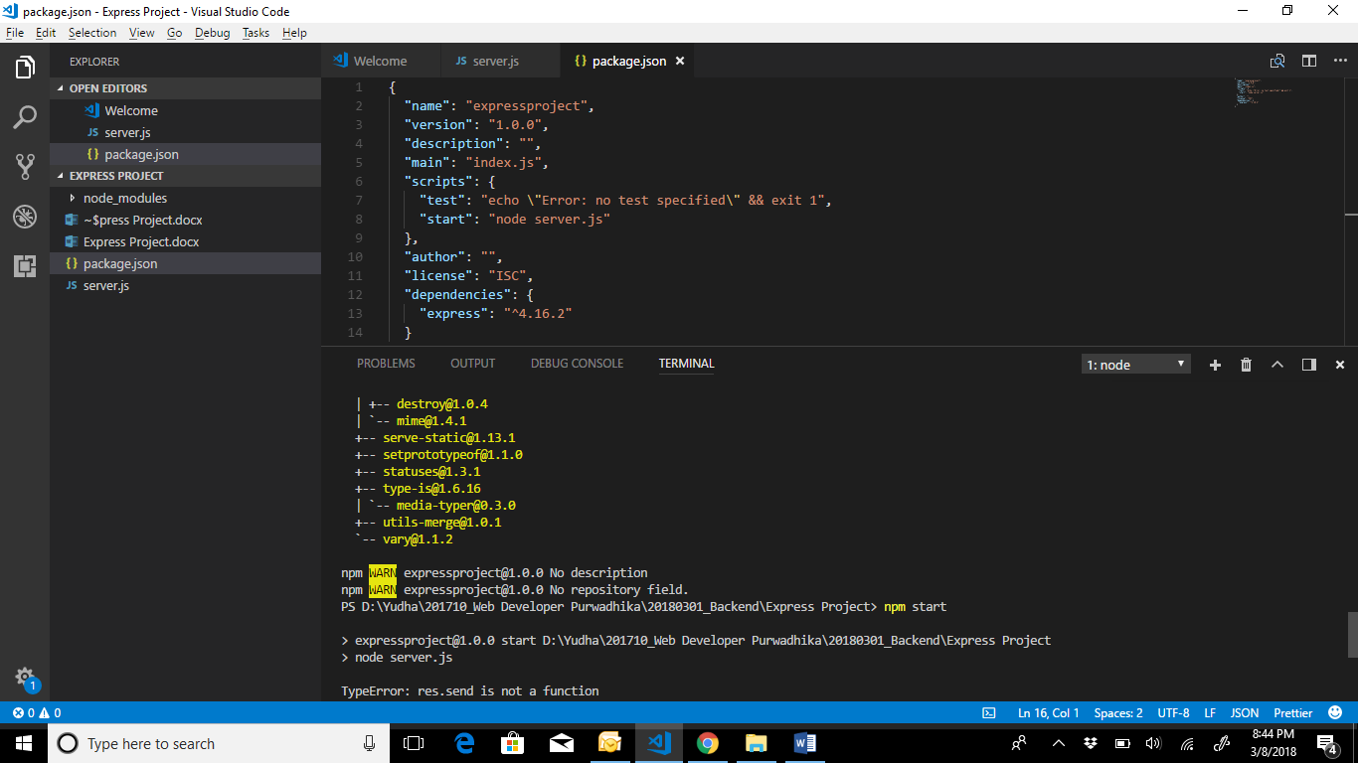

Di browser localhost:3000

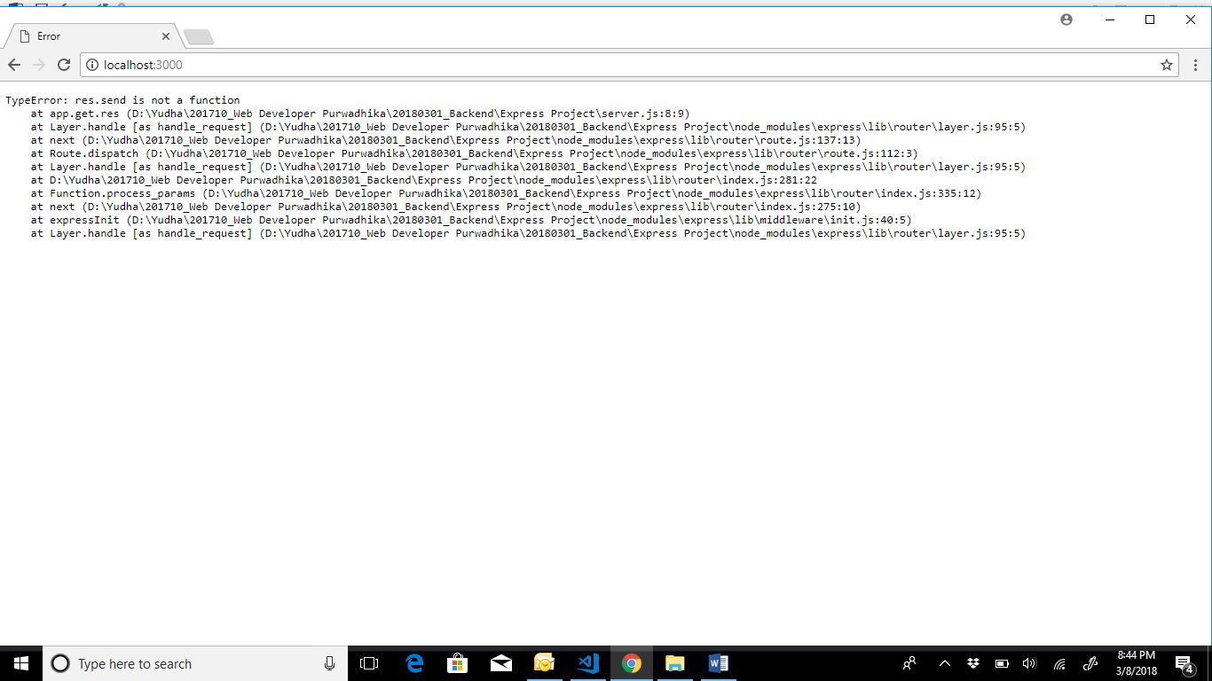

Di server.js kasi parameter untuk ambil (request) dan kasi (respond)

//calling library

const express = require ('express')

//we use express

const app = express()

app.get('/', (request, respond) => {

respond.send('Hello World')

})

app.listen(3000)

Bikin folder dan file.js di kiri

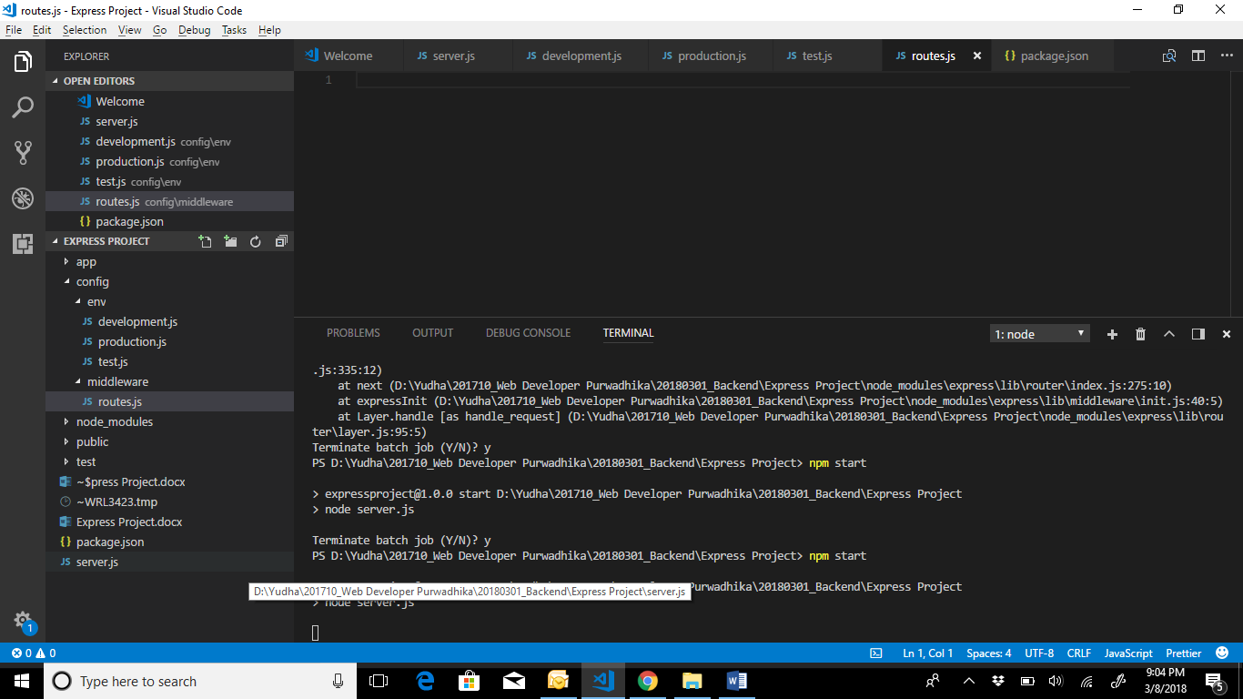

Test tampilan baru:

Di routes.js ketik

//routing

module.exports = (routing) => {

routing.get ('/', (request, respond) => {

respond.send('Hello World')

})

routing.get('/:id/:name', (request, respond) => {

respond.send({

id: request.params.id,

name: request.params.name,

})

})

}

Di server.js ketik

//calling library

const express = require ('express')

//we use express

const app = express()

const router = require('./config/routes')

router(app)

app.listen(3000)

hasilnya

